# Import a JSON file from the command line. Apply the following actions with the data present in the JSON file where, projection, aggregation, remove, count, limit, skip and sort

**AIM:**

To import a JSON file from the command line and apply the following actions with the data present in the JSON file where, projection, aggregation, remove, count, limit, skip and sort using MongoDB.

# PROCEDURE:

1. Install and Set path jq to apply actions on the JSON file.
2. After performing step 1 check for jq version to confirm the installation.

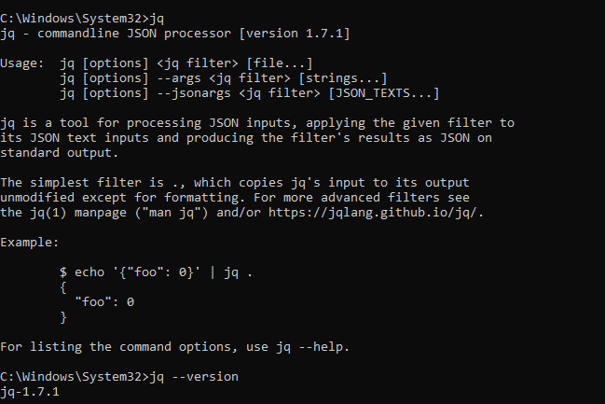

1. Give following comments of jq to perform projection, aggregation, remove, count, limit, skip and sort using jq.

* Projection (Select Specific Fields): Display only the name and salary fields: jq '.[] | {name: .name, salary: .salary}' C:\Users\prade\Documents\da\_lab\json\employees.json

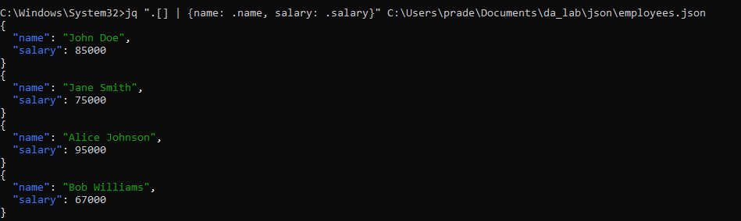

* Count the Number of Employees:

jq '. | length' C:\Users\prade\Documents\da\_lab\json\employees.json

IMG_256

* Remove (Filter Out Specific Records): Remove the phone number of the employees:

jq 'del(.[] | .phoneNumber)' C:\Users\prade\Documents\da\_lab\json\employees.json

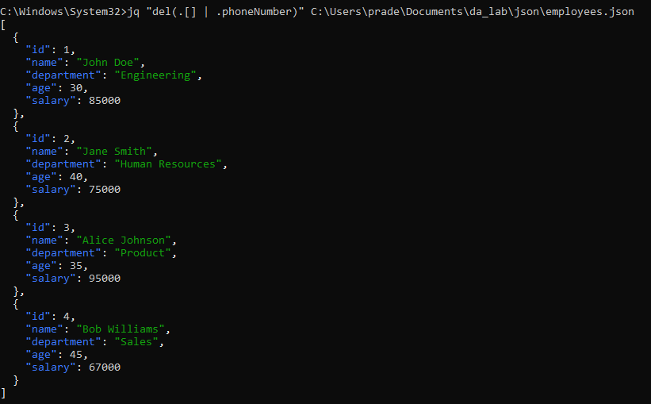

* + Limit (Limit the Output): Display only the first 2 employees: jq '.[0:2]' C:\Users\prade\Documents\da\_lab\json\employees.json

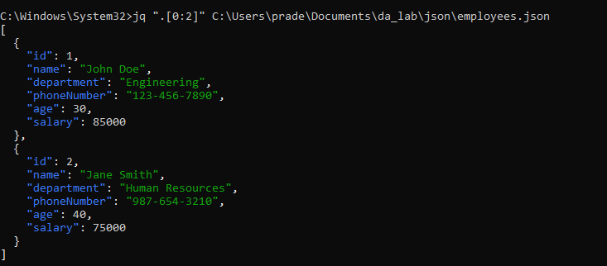

* + - Skip (Skip a Number of Records): Skip the first employee and display the rest:

jq '.[1:]' C:\Users\prade\Documents\da\_lab\json\employees.json

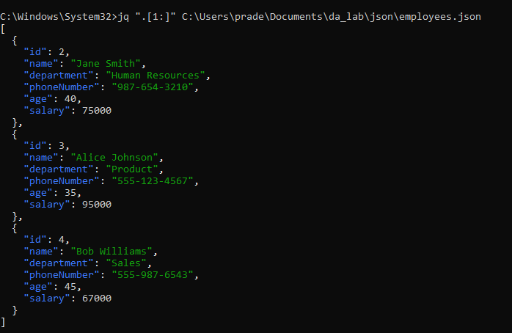

* + - Sort (Sort by Salary): Sort employees by salary in ascending order:

jq 'sort\_by(.salary)' C:\Users\prade\Documents\da\_lab\json\employees.json

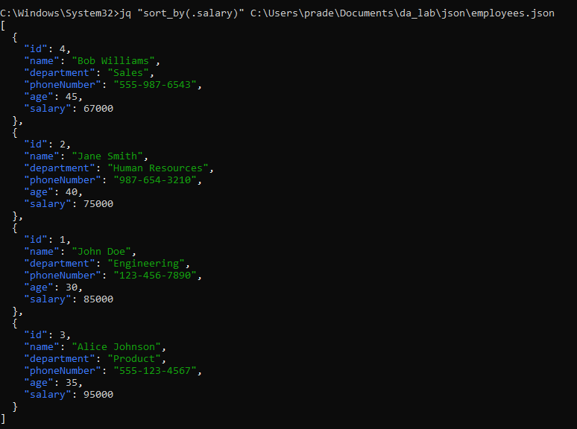

* + - * Aggregation (Calculate Total Salary): Calculate the totalsalary of employees:

jq '[.[] | .salary] | add' C:\Users\prade\Documents\da\_lab\json\employees.json

IMG_256

**RESULT:**

Thus to import a JSON file from the command line and apply the following actions with the data present in the JSON file where, projection, aggregation, remove, count, limit, skip and sort using jq is completed successfully.